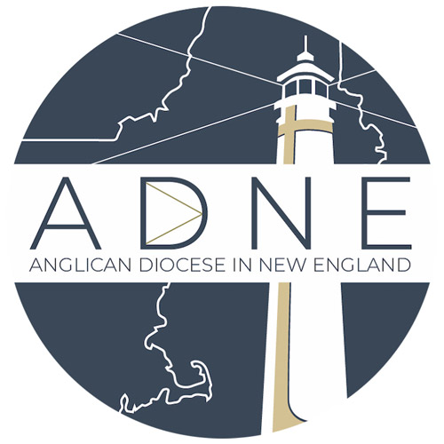
Anglican Diocese in New England
Non-Anglican Clergy Application

Application from a Minister ordained in a Jurisdiction not in Communion with the Anglican Church in North America

This application is necessary for all clergy ordained in a denomination NOT in Communion with the Anglican Church in North America (ACNA) who wish to be ordained or received in the ACNA under the Anglican Diocese in New England (ADNE). Clergy previously in a jurisdiction not in communion with the ACNA may seek to be ordained to the diaconate and the presbyterate in the ACNA. ACNA Canon Title III, Canon 5.1 and 2. Clergy previously ordained in a jurisdiction by a bishop of the historic succession but not in communion with the ACNA may seek reception in the ACNA in the Orders to which s/he was previously ordained. ACNA Canon Title III, Canon 5.3.
Please fill out the information below using the gray boxes, which will expand as you type. Use the tab key to navigate directly into each gray box. Save the form and email it with your other ordination materials to ross.kimball@adne.org or you may also print and mail it in together with your discernment packet to Rev. Canon Ross Kimball, The Anglican Diocese in New England, 6 Allens Ct. Amesbury, MA 01913. If you have any questions about this document, feel free to email our offices at the above email address or call 978.388.0650.

Personal Information
Title: Other:
First name:
Middle Name:
Last Name:
Suffix:
Sex:
Birth Date (dd/mm/yyyy):
Home Address:
Home Phone:
Cell Phone:
Primary Email address:

Professional Information
Church Branch:
Ordination (Order):
Date of ordination (dd/mm/yyyy):
Ordaining Denomination:
Seminary Attended (if applicable), Degree: Year:
Name of the congregation in which you currently serve or worship:
Number of years in that congregation:

References

Name | Email address | Telephone | Relationship to applicant
1.)
2.)
3.)

Questions:
Briefly explain why you are seeking ordination in/reception into the ACNA (if necessary, complete your answer on a separate sheet of paper and attach it hereto):

The Anglican Diocese in New England is a family of churches united in Word, Spirit, Sacrament and Mission. Please describe how these four components inform and shape your ministry (if necessary, complete your answer on a separate sheet of paper and attach it hereto):

Briefly explain what preparation you believe you may need to prepare for ordination/reception in the ACNA and serving Christ in the Anglican way:

Affirmation
(Prior to returning your application please read the Constitution and Canons of the Anglican Church in North America (www.anglicanchurch.net) and the Anglican Diocese in New England (www.adne.org).

I, , attest that I have read and affirm the Constitution and Canons of the Anglican Church in North America and the Anglican Diocese in New England and am seeking (ordination / reception )in this church through the Anglican Diocese in New England under The Right Reverend Andrew T. Williams, bishop. I understand that I will be examined as required by Title III, Canon 3, Section 1 prior to being ordained/received and am willing to participate in a pre-ordination process to prepare me for ordination.

Signature:
Date:
*Please enclose a check made out to ADNE for $165.00 to cover the costs of an Oxford Background Check.

