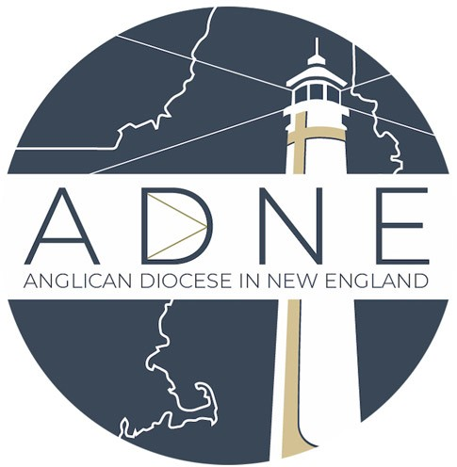
Application for Licensure and Licensure Renewal
In the Anglican Diocese in New England While Canonically Domiciled in Another Jurisdiction

It is expected that clergy who are not canonically domiciled in the ADNE but who wish to function in any ADNE church will apply to be licensed by the bishop of the ADNE, currently The Rt. Rev. Andrew Williams, of renew their license after it expires.

To apply for or renew licensure with the ADNE, type your information in each gray box. The boxes will expand as you type. Use the tab key to navigate directly into each gray box. Save the form and email it to adne@adne.org with your resume. You may also print and mail it to The Anglican Diocese in New England; 6 Allens Ct. Amesbury, MA 01913. If you have any questions about this document, feel free to email our offices at the above email address or call 978.388.0650.

Is this a licensure renewal? Yes No

If “Yes” then please fill out your original date of licensure: If applicable, fill out the date of your previous renewal:

Personal Information
Title: Select Other:
First name:
Middle Name:
Last Name: Suffix: Sex: Select
Birth Date (day, month, year): Home Address:
Home Phone:
Cell Phone:
Primary Email address:

Professional Information
Seminary Attended, Degree, Year:

Ordination: Select
Date ordained Deacon: Month Day Year Ordaining Bishop and Diocese:
Date ordained Priest (if applicable): Month Day Year Ordaining Bishop and Diocese:
Name of diocese/jurisdiction in which you are currently canonically domiciled: Name of Bishop under which you are canonically domiciled:
Name of the congregation in which you currently serve or worship (please include the name of the congregation’s diocese if not under the jurisdiction in which you are domiciled):
Position:
Have you had a background check completed within the last 5 years? Yes No If yes, in what jurisdiction was this done?

Family Information (If applicable)
Full name of Spouse:
Spouse’s contact phone:
Spouse’s email:
Spouse’s birth date:
List the names of your children (Please use the first names by which the children are called) and their birth dates:
Child #1: Name | Month | Day | Year | Sex:
Child #2: Name | Month | Day | Year | Sex:
Child #3: Name | Month | Day | Year | Sex:
Child #4: Name | Month | Day | Year | Sex:
Child #5: Name | Month | Day | Year | Sex:

Child #6: Name Month Day Year
Sex:

We ask all licensed clergy to review the Constitution and Canons of the Anglican Church in North America and the Anglican Diocese in New England at the time of application and renewal.

I have re-read the Constitution and Canons of the Anglican Church in North America and the Anglican Diocese in New England. W- L

We require all our licensed clergy and staff to complete the Ministry Safe training course for the care and protection of children. This certification lasts for two years; if you have not yet completed it or need to renew your certification, please email the ADNE diocesan office at adne@adne.org.

I have completed the Ministry Safe training course for the Protection of Children within the past two years: Y / N

At this point in time, are you considering or interested in transferring to The Anglican Diocese in New England to become canonically resident in New England under its Bishop, currently the Rt. Rev. Andrew Williams?

This document, completed by (Name) indicates my desire for licensure with the Anglican Diocese in New England for the following year, and is submitted to the diocesan office and the authority of the acting Bishop of the Anglican Diocese in New England for their consideration and approval.

Signature:

or Electronic Signature:

Date:

*Upon reception of your documentation, the diocesan office will contact you to schedule an appointment with Bishop Williams

